Computer Language Diagrams

Value Assignment in a Diagram
About the notation of assignment in general, see the article Assignment in a Diagram.

The principle of value assignment is explained in the article Value Assignment. This article demonstrates the expression of it in a diagram.

To distinguish value assignment from other types of assignment such as object assignment, value assignment gets a special symbol:

This symbol is the identifier for value assignment.
It is an equals sign with a V in it, which stands for value.

As such, a value assignment in a diagram looks like this:

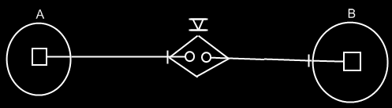

See also: Assignment in a Diagram, Value Assignment

Author & Copyright: Jan-Joost van Zon Date: May 24, 2008 – May 24, 2008 Location: Oosterhout, The Netherlands Status: Finished

